Experiment no :- 8

Aim :- Application of What –If analysis for data visualization

Theory :-

* **What**-**If Analysis** is the process of changing the values in cells to see how those changes will affect the outcome of formulas on the worksheet.
* Three kinds of **What**-**If Analysis** tools come with **Excel**: Scenarios, Goal Seek, and Data Tables.

Scenarios :-

* But what if you sell 70% for the highest price? And what if you sell 80% for the highest price? Or 90%, or even 100%? Each different percentage is a different scenario. You can use the Scenario Manager to create these scenarios.
* Note: You can simply type in a different percentage into cell C4 to see the corresponding result of a scenario in cell D10. However, what-if analysis enables you to easily compare the results of different scenarios.

Step 1:-

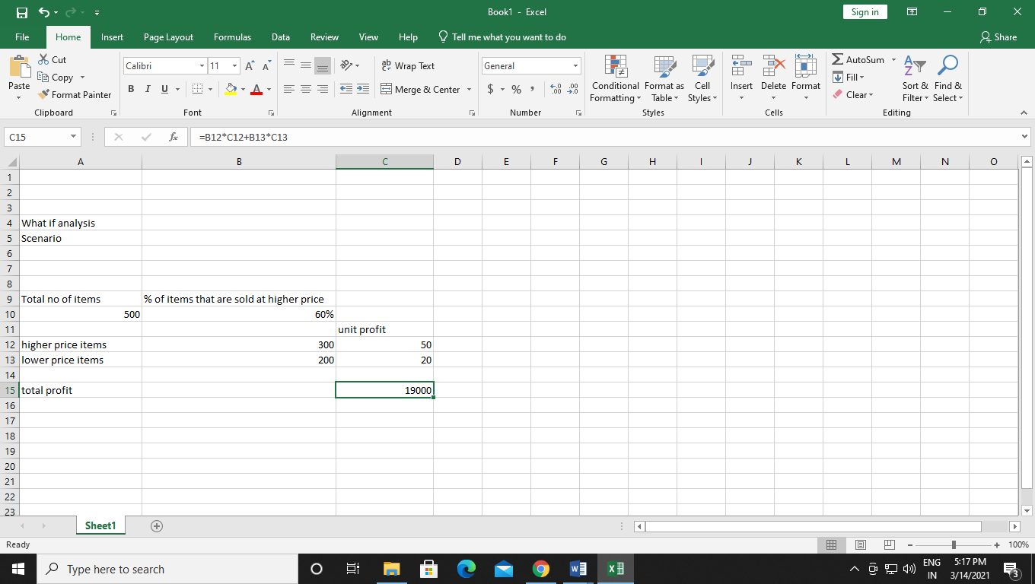

Step 2:- on the data tab , in the Forecast group . click what- if Analysis .

Than click on Scenario Manager

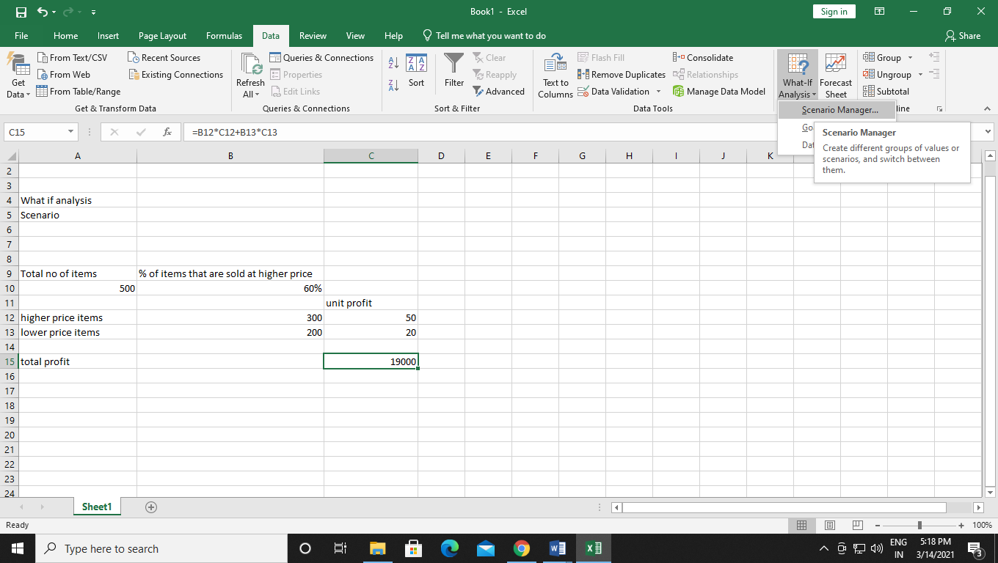

Step 3:- Add a Scenario by clicking on add than type a name (50 % highest ), select cell C15 (%Sold for the highest price ) for changing cells and click on Ok

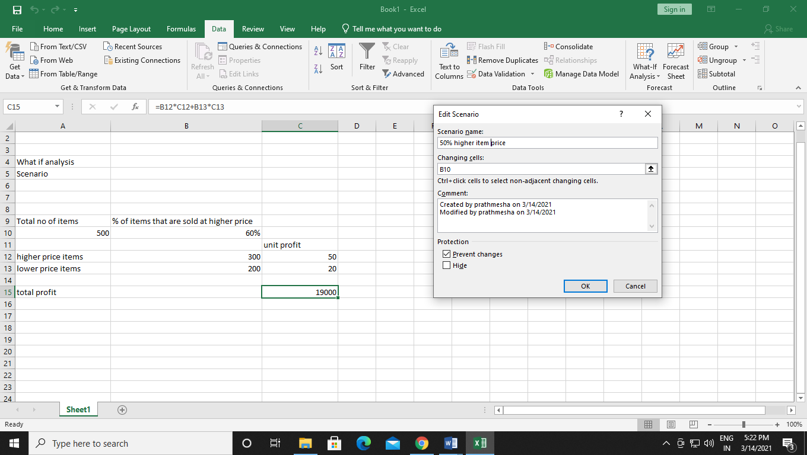

Step 4 :- Enter the Corresponding value 0.5 and click on OK again

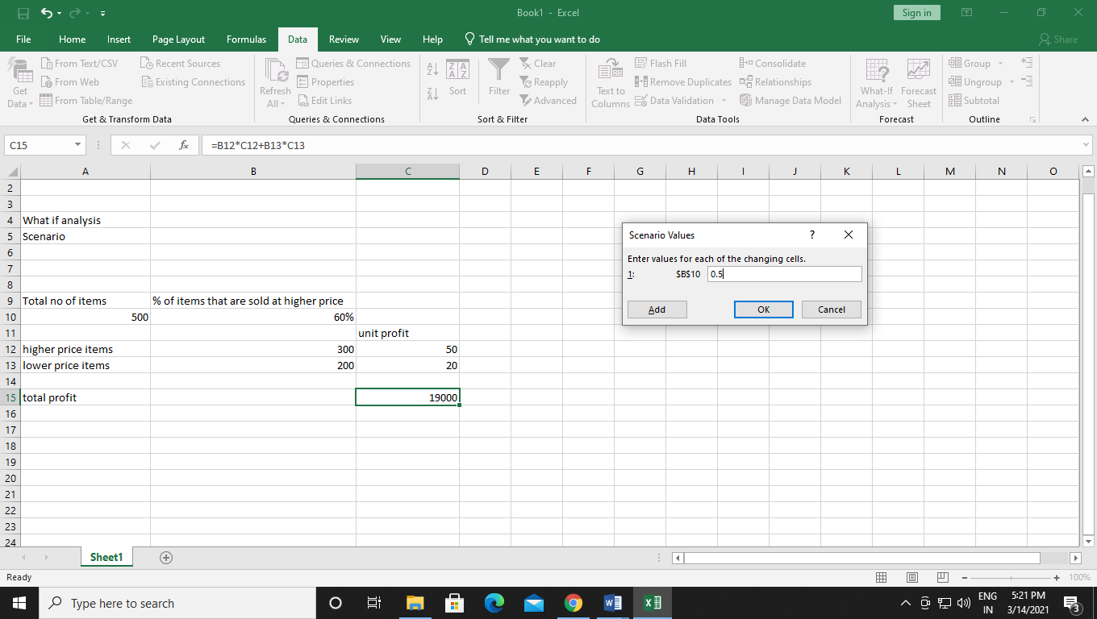

Step 5:- Add 4 other scenarios (60%, 70%, 80%, 90%)

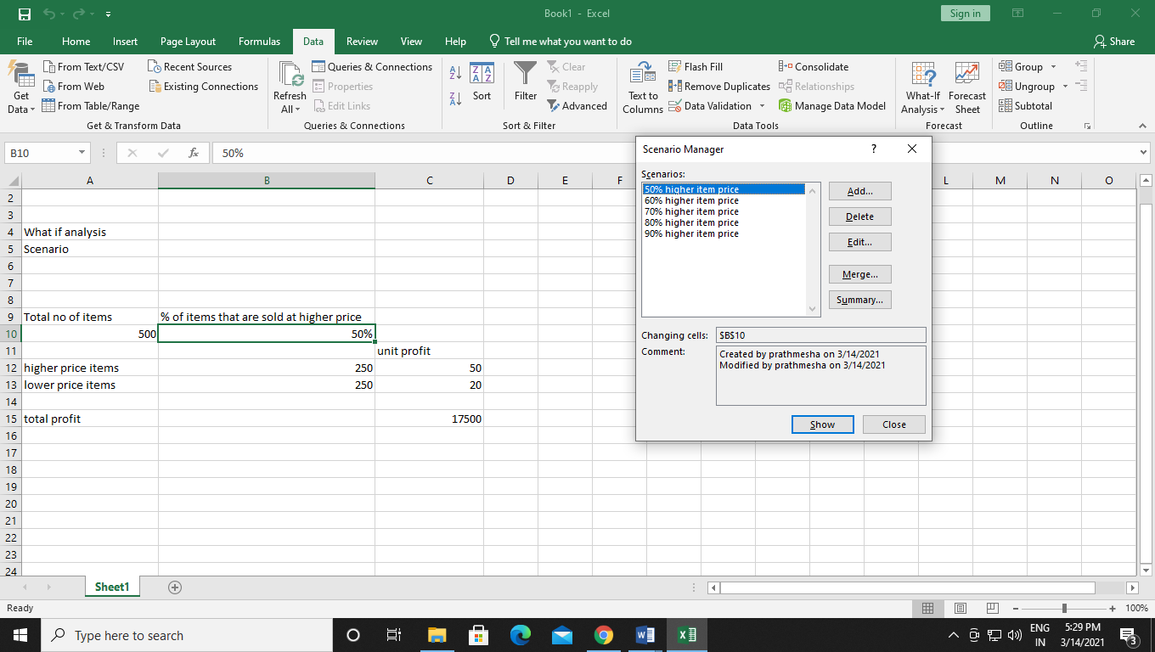

Step 6 :- To easily compare the results of these scenarios, execute the following steps.

a. Click the Summary button in the Scenario Manager.

b. Next, select cell C15 (total profit) for the result cell and click on OK.

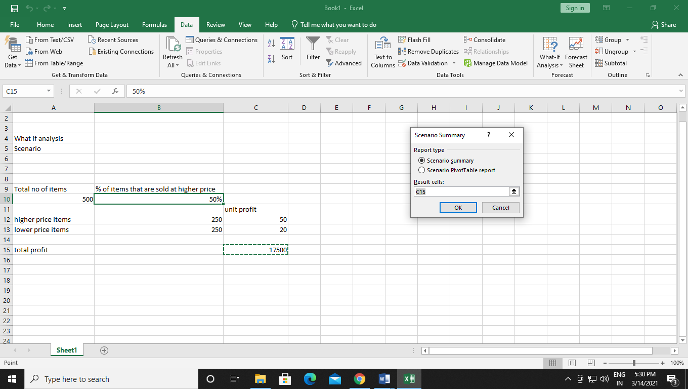

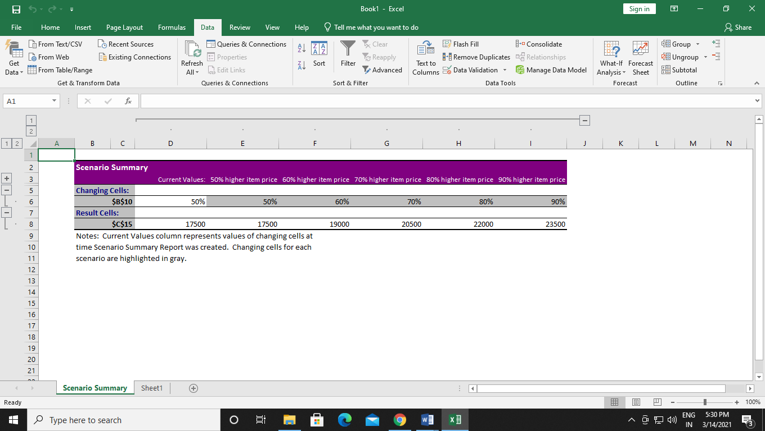

Goal Seek :-

Step 1:- on the data tab, in the forecast group click what-if analysis than click on goal seek.

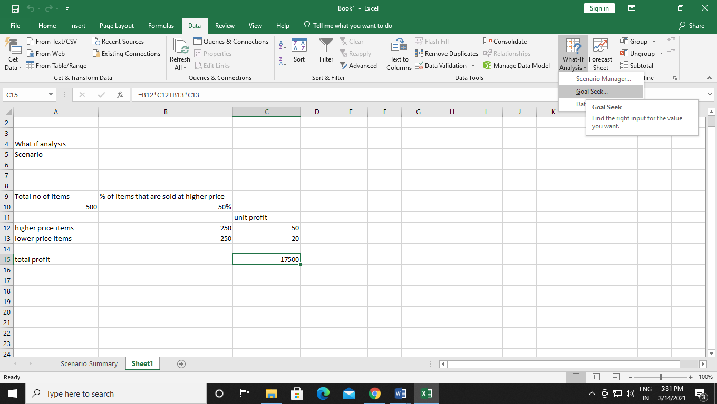

Step 2:- select cell C15 , Click in the ‘to value ‘ box and type 22500 , click in the ‘ by changing cell box ‘ and select cell B9 than click ok

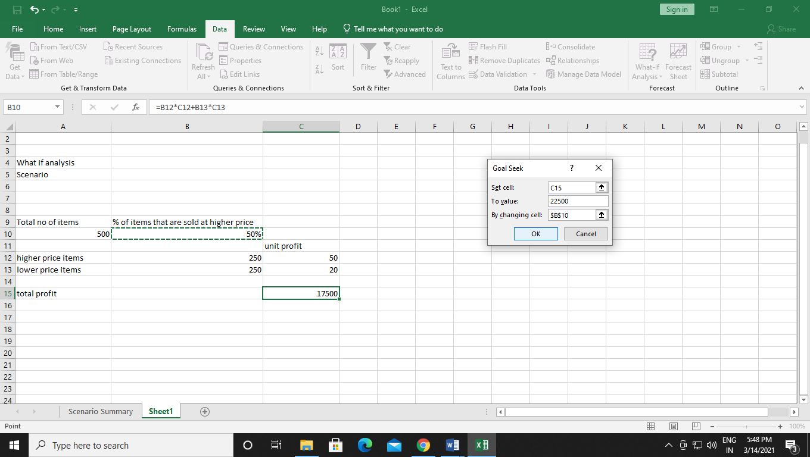

Step 3:- results we need to sell 83% percent of product / item on higher price to get 22500 profit

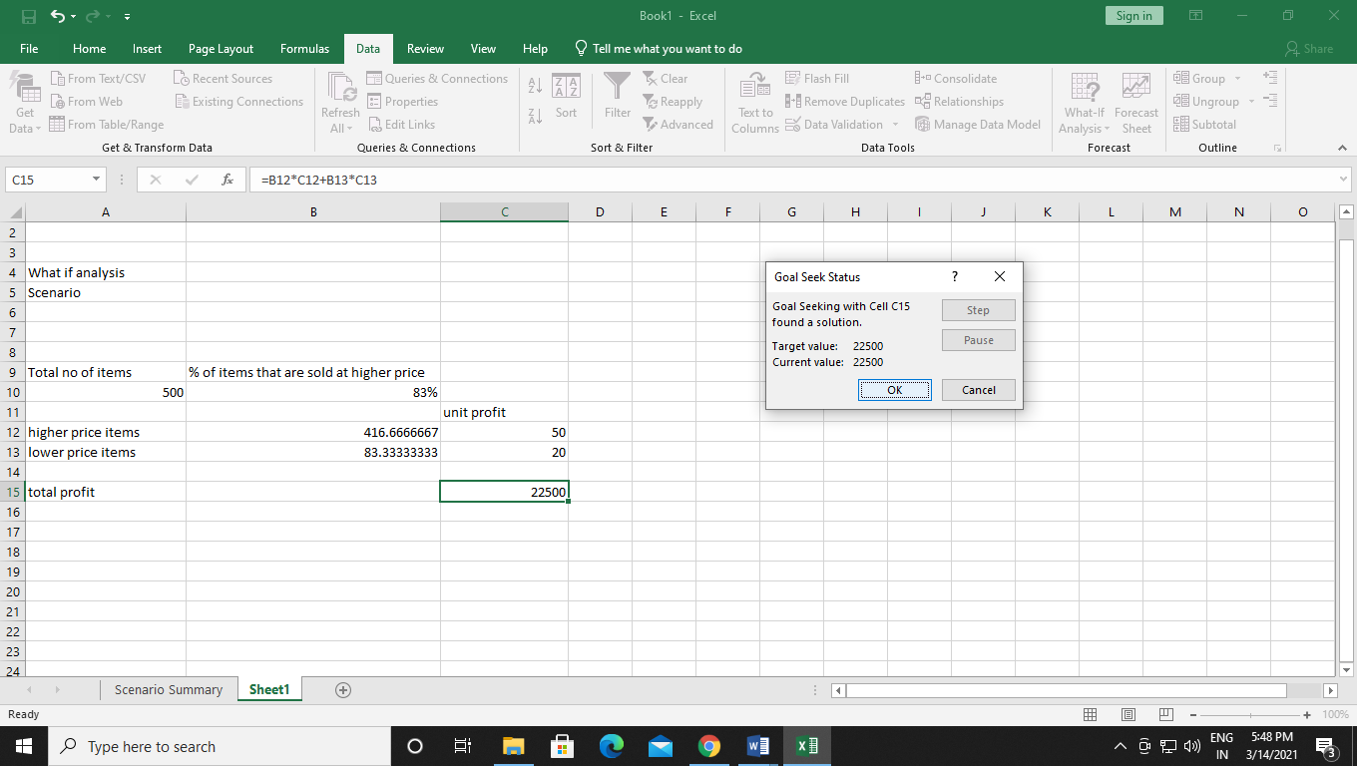

Data table in Excel

* In Microsoft Excel, a **data table** is one of the What-If Analysis tools that allows you to try out different input values for formulas and see how changes in those values affect the formulas output.
* Data tables are especially useful when a formula depends on several values, and you'd like to experiment with different combinations of inputs and compare the results.

Creation of a one variable data table in Excel

* **One variable data table** in Excel allows testing a series of values for a **single input cell** and shows how those values influence the result of a related formula.

Step 1:- on the data tab, in the forecast group click what-if analysis than click on data table.

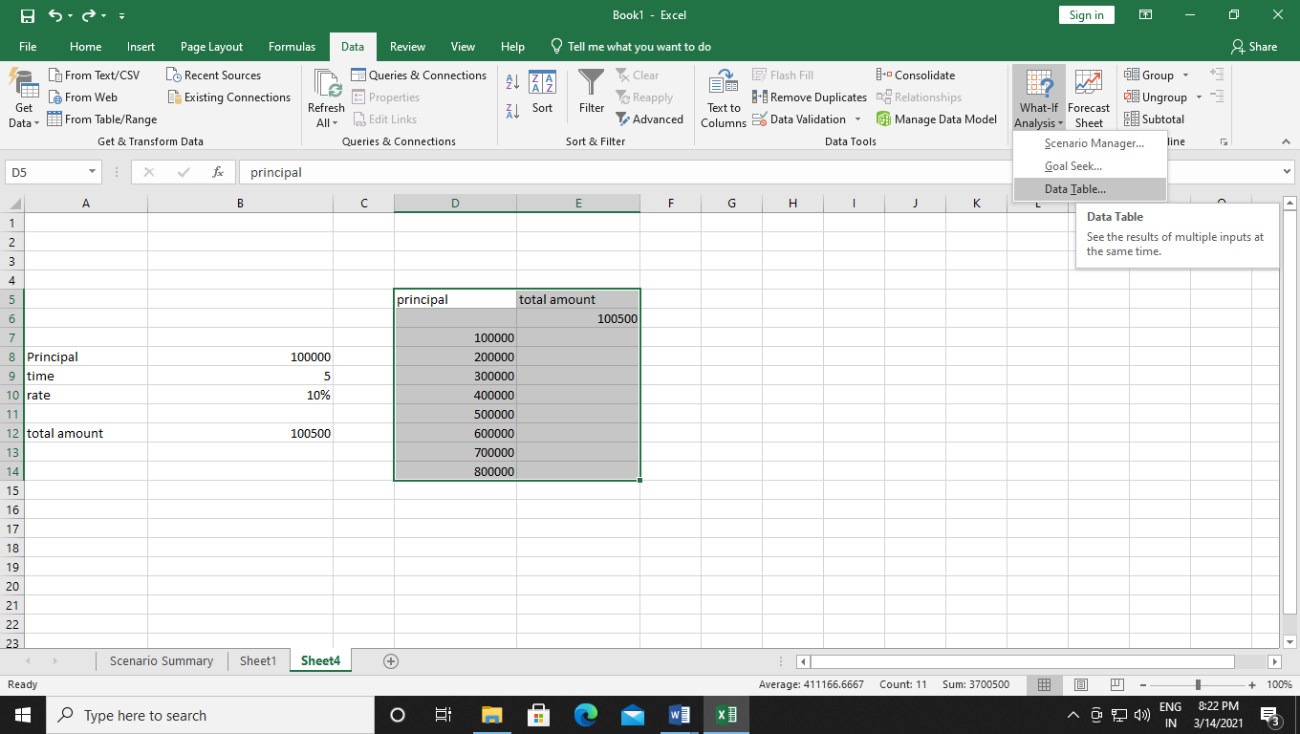

Step 2:- click on column input then select f33 than click ok.

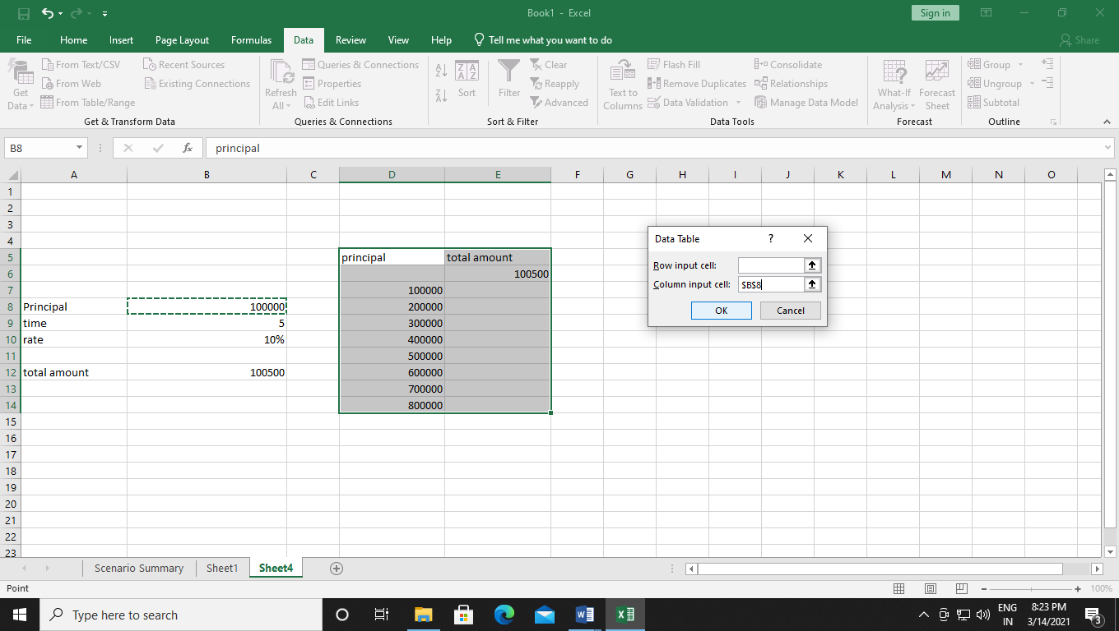

Step 3:-

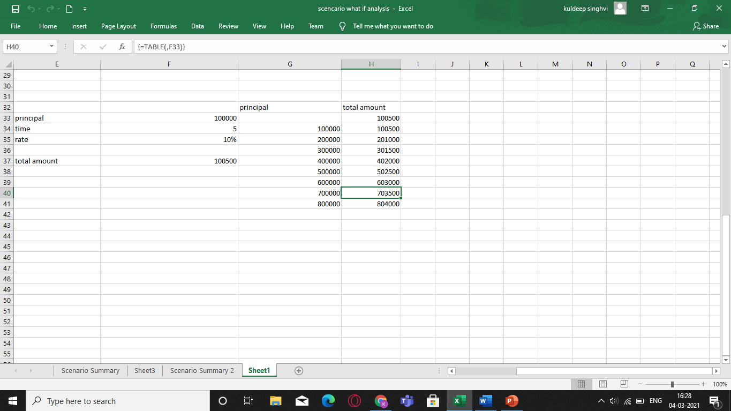

Creation of a two variable data table in Excel

* A **two-variable data table** shows how various combinations of 2 sets of variable values affect the formula result. In other words, it shows how changing two input values of the **same formula** changes the output.
* The steps to create a two-variable data table in Excel are basically the same as in the above example, except that you enter two ranges of possible input values, one in a row and another in a column.

Step 1:- on the data tab, in the forecast group click what-if analysis than click on data table.

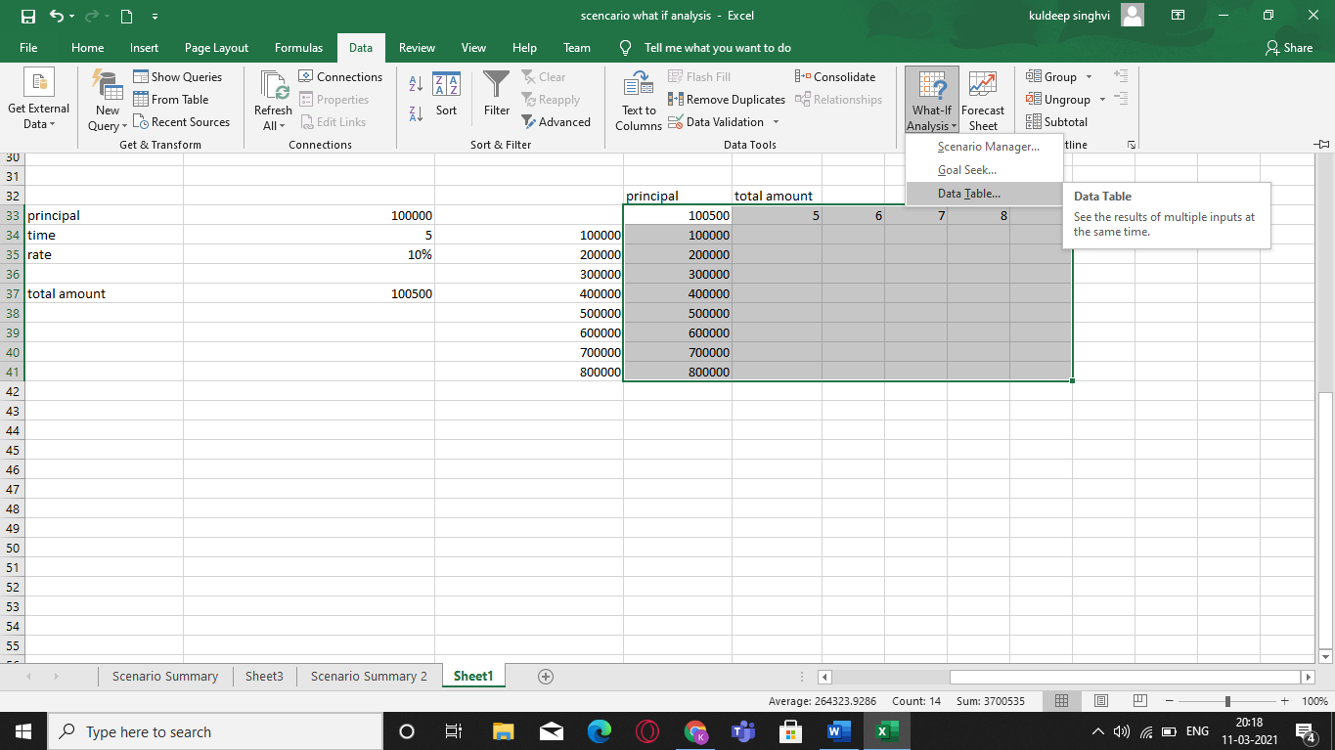

Step2 :-

